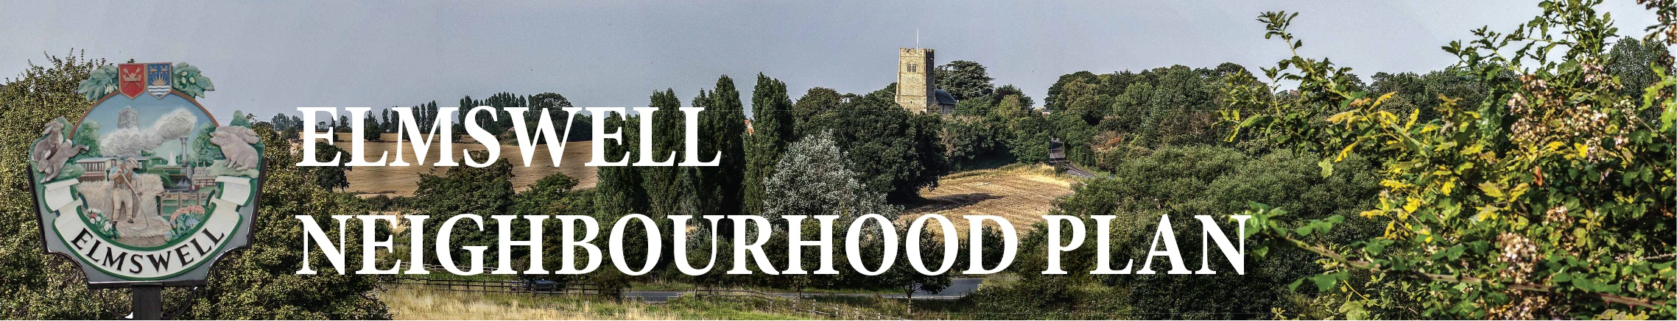

Minutes
of the Steering Group meeting held on 16th October 2014 at The Blackbourne
Members Present Marian Abbott, Philip Blissett, Julie Cole, Peter Dow, Peter Edmonds,
Terry Garner, Peter Goodridge, Sarah Mansel (Ch.), Ann Richards.
Attending Robert Horn of CAS
1 Apologies were received from Neil Brown, Mary Feeney, Fred Pallett & Shaun Pratt.
2 The Minutes of the last meeting on 18th September were approved as a true record.
3 There were no matters arising from the Minutes not dealt with as an Agenda item.
4 There was an overall review the latest draft of the Household Questionnaire when it was agreed to
delete Q19.6 re disability access as it was already represented. Otherwise the document was
considered to be appropriate for consultation with village groups.
5 In discussion regarding the consultation with village groups, it was agreed that:
5.1 The consultations should, ideally, take place before the end of January;
5.2 The sports clubs could be invited all together to a joint session;
5.3 Young people’s organisations (adult helpers) eg playgroup, uniformed groups, youth club,
could all be invited to joint session;
5.4 Other groups identified as Over 55’s, 2 x WI, History group, Exchange Club;
5.5 If any group cannot accommodate us, questionnaires could go to them for circulation and comment back to us;
5.6 Philip will clear it with Exchange Club & History Group and be one of the presentation team;
5.7 Presentation teams of 2, spread as widely across our group as is feasible;
5.8 Marian & Julie will do FRESCH (PTA);
5.9 Substance of each presentation to include the purpose of NP, its status in Planning law, the fact
that it is not a Village Plan and the difference explained, explanation of the distribution / return /
collation process & stress the advantages of on-line returns, distribute to all attending a draft
questionnaire including map of the Civil Parish with settlement boundary marked;
5.10 Invite feedback both at the sessions and later as necessary;
5.11 Peter D to draft a letter from Sarah to go to groups ASAP inviting suggestions as to dates;
5.10 Peter D to draft a presentation ‘framework’ for consideration at next meeting.
6 There was a review of the draft Youth Questionnaire from which it was agreed that only one tick box is
needed and that the question structure is basically sound.
6.1 Marian & Julie agreed to approach Elmswell School towards arranging distribution of
questionnaires to be timed to coincide with the main Household Questionnaire distribution in the
hope that one might encourage the other.
6.2 Peter D to make enquiries of Thurston towards establishing a point of liaison.
6.3 A feature in the Newsletter will suffice in terms of catching children slipping through the net of the approaches to Elmswell & Thurston schools.

7 The Business Questionnaire draft was reviewed and Peter D undertook to take the suggestions away
and re-draft for the next meeting.
8 Ann reported that she had installed the exhibition at the recent Rural coffee Caravan information &
networking day – the Golden Age Fair – at Blackbourne and that Peter Edmonds had taken
photographs of interested parties at the stand. There were 7 comments left in the box, effectively:
3 Something must be done about the railway crossing if Elmswell is to expand
1 There should be more recreation space for a growing population – an all weather pitch can be a
goldmine as in Walsham @ £25.00 per hour (to non village users)
1 I hope this is more useful than the Village Plan was that I helped with a few years back.
1 We need a car park in the middle of the village.
9 There was general discussion regarding the possibility of a ‘prize’ incentive system to encourage questionnaire returns from which no firm conclusion emerged.
10 The next agenda to include:
10.1 A revised Business questionnaire draft;
10.2 Revisit the ‘incentive’ idea;
10.3 Consider a draft framework for presentations – Peter D to circulate in advance;
10.4 Update on letters sent to groups suggesting consultation.
11 The date for the next meeting was fixed as Thursday 13th November at Blackbourne.
12 The meeting closed at 9.25.
Peter Dow

